# Controlling Physiotherapy for Physically Challenged Person

***Abstract*—Improvising the situation of physically challenged person in wheelchair with additional features of temperature monitor, medication reminders , alert system to check urine bag and a leg lifter for exercise. It quite helps them without a physiotherapist.**

1. INTRODUCTION

Physical disabilities can be caused by a number of factors, such as ageing, health problems, and accidents. As a result, a wheelchair is required for individuals with disabilities who wish to participate in some forms of physiotherapy. Wheelchair is an essential vehicle for people with physical disability in order to do physiotherapy every day. The self-controlled type of wheelchair, is the user needs to operate the wheelchair with hands using a rim equipped at the outside of the rear wheel and physically challenged person can do the exercises on wheelchair. This type of the wheelchair is equipped with the Arduino uno R3 to control the wheelchair to do exercises effectively. Therefore, many researchers have proposed different techniques to control the wheelchair such as the face detection [3], oral motion [4], eye gaze [5], tongue pressure [6], bio-signal [7], electromyography. (EMG) [8].Electrooculography(EOG) [9] and electroencephalography (EEG) [10]. However, another possible method is to use the voice to operate the moments of the wheelchair.

This paper describes the design and development of a controlling physiotherapy for physically challenged person. In addition the wheelchair is equipped with the urine detector sensor, medicine remainder, body temperature sensor. These are some of additional features in this wheelchair.

II. METHODS

The block diagram and circuit diagram of figure 1, figure 2, figure 3 used for physiotherapy and monitors the disabled person. When Switch turned on the whole Arduino uno r3

activates through the power supply 9v. Then temperature sensor gets the signals from the user in the form of physical signal .This physical signal is converted into electrical signal by the temperature sensor that signal is given to the Arduino uno r3. The Arduino signal gives the output of 4 digits 7 segment display. By this display the user can monitor their temperature being in their wheelchair itself . Certain commands are given to the Arduino that controls the motor control module. The motor control prevents from overload protection, speed changing, jogging and also secures the user. From the motor control module, the signal goes to left motor 1 and 2 as well as right motor 3 and 4. Both left and right motors performs the clockwise and anticlockwise rotation. The right motors are fixed in right footplate and left motor are fixed in left footplates .which helps to move the leg up and down. It helps achieve the leg movements of the user in wheelchair itself. When the user turns off the switch the entire Arduino turns off. The figure 2 device located in the urine bag of the user. Which does not belong to the Arduino connections. It has separate microcontroller. Water level sensor is inserted in the urine bag. Water level sensor gives the input signal of urine level that contains in bag to the micro controller.

The signal gives the indications to user through LED. The output Of the LED gives various level indications .The green

light indicates low level; yellow light indicates moderate level and red light indicates the bag is full. Therefore, buzzer alerts the user and caretaker. The figures 3 explains the smart medicine reminder that helps to remind the user to intake the medicine on time through the displays in the LCD and with a buzzer. The user can set time for an alarm to intake medicines. RTC gives the input signal to the Arduino nano for the real time information. If that information and user time are same then the buzzer sound continues for one minute . Then in the LCD displays “Take your BP tablet" or some medicine name. This process continuous throughout the day ( morning, afternoon, night).

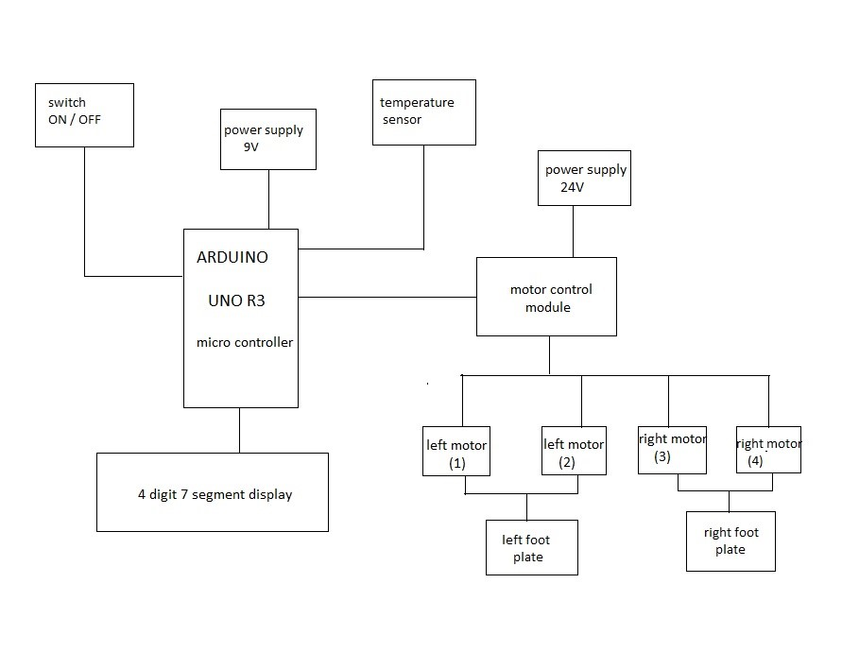

Figure 1. Schematic diagram of the exercise wheelchair.

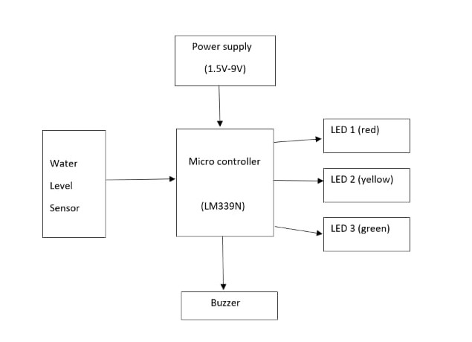

Figure 2. Schematic diagram of the urine level detector.

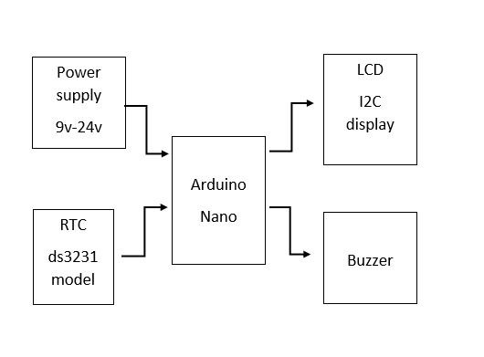

Figure 3. Schematic diagram of the smart medicine remainder.

## A. Microcontroller unit

Arduino UNO is a microcontroller board based on the ATmega328P. It has 14 digital input/output pins 6 analog inputs, a 16 MHz ceramic resonator, a USB connection, a power jack, an ICSP header and a reset button.

It contains everything needed to support the micro --controller and simply connect it to a computer with a USB cable or power it with a AC-to-DC adapter or battery to get started.

## B. DC motor 45rpm

A geared DC Motor has a gear assembly attached to the motor. The speed of the motor is counted in terms of rotations of the shaft per minute and is termed as RPM. The gear assembly helps in increasing the torque and reducing the speed. Using the correct combination of gears in a gear motor, its speed can be reduced to any desirable figure.

## C. Body Temperature Sensor

Temperature sensors are devices that detect and measure coldness and heat and convert it into an electrical signal Temperature sensors are utilized in our daily lives, be it in the form of domestic water heaters, thermometers, refrigerators, or microwaves. There is a wide range of applications of temperature sensors, including the geotechnical monitoring field.

## D. Waterlevel sensor

The water level sensoris a device that measures the liquid level in a fixed container that is too high or too low. According to the method of measuring the liquid level, it can be divided into two types: contact type and non-contact type. The input type water level transmitter we call is a contact measurement, which converts the height of the liquid level into an electrical signal for output. It is currently a widely used water level transmitter.

## E. Real time clock

A real time clock, or RTC, is a digital clock with a primary function to keep accurate track of time even when a power supply is turned off or a device is placed in low power mode. RTC’s are comprised of a controller, oscillator, and an embedded quartz crystal resonator.

## F. Motor Control Module

Motor controllers may include some or all of the following motor control functions: starting, stopping, over-current protection, overload protection, reversing, speed changing, jogging, plugging, sequence control, and pilot light indication.

## G. Power Supply

The electrical voltages of 9V, 12V and 24V are used to supply to the microcontroller system and the motor control module respectively.

## H. Buzzer

A buzzer or beeper is an audio signalling device, which may be mechanical, electromechanical, or piezoelectric (piezo for short). Typical uses of buzzers and beepers include alarm devices, timers, train and confirmation of user input such as a mouse click or keystroke.

*I. Liquid Crystal Display*

LCD (Liquid Crystal Display) is a type of flat panel display which uses liquid crystals in its primary form of operation. LEDs have a large and varying set of use cases for consumers and businesses, as they can be commonly found in smartphones, televisions, computer monitors and instrument panels.



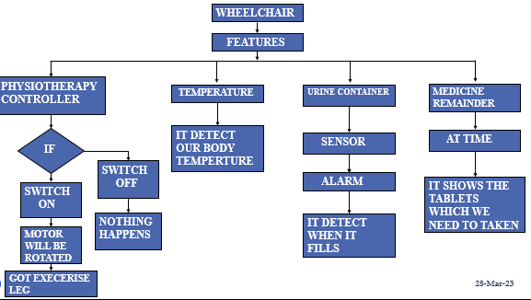



s

III. RESULTS

Based on the above experiment, we conclude that our newly implemented the leg lifter for exercise purpose. Smart medicine remainder for disabled persons to take their medicine on time. Detecting the urine level in the urine bag of the disabled person.

Regularly monitors the body temperature of the disabled person in the wheelchair. By this implementation in the wheelchair the disabled person can able to do their activity on their own without others help.

IV. DISCUSSIONS AND CONCLUSIONS

We discussed about the disability person’s main problem is not doing their exercise on their own. Their need to perform the physiotherapy exercise without the help of the physiotherapist or any other physiotherapy equipment. To avoid separate equipment for physiotherapy we implemented leg lifter exercise in the wheelchair itself. And to monitor their body temperature ,urine level contained in the urine bag and medicine remainder is used to indicate the user or care taker to take the particular medicine on time.

In conclusion, the controlling physiotherapy is successfully developed. This physiotherapy activity can be achieved by four dc motor on both the sides of foot plate in the wheelchair. whenever the disabled person need to check the body temperature they can able to check the temperature in the wheelchair. In case the urine bag is full it will indicate through the buzzer and the LED indication to the user and the care taker. By the help of the medicine remainder the user can able to take their medicine on time with any delay in timing.

REFERENCES

1. M. Khalili, G. Kryt, H. F. M. Van der Loos and J. F. Borisoff. A Comparison Between Conventional and Terrain-Specific Adaptive Pushrim-Activated Power-Assisted Wheelchairs, vol 29, no. 4, pp. 3486-0651, Dec 2021
2. B.Ayshwarya and R.Velmurugan. Intelligent and Safe Medication Box In Health IoT Platform for Medication Monitoring System with Timely Remainders, pp. 2079-9884, June 2021.
3. Xin Chen , Jian Wang, Ling-Li Zeng , Jinfang Liu , and Dewen Hu. Clinical Validation of BCI-Controlled Wheelchairs in Subjects With Severe Spinal Cord Injury, vol 30, no. 5, pp. 3529-9107, Mar 2022.
4. Louise Devigne, Marco Aggravi, Morgane Bivaud and Nathan Balix. Power wheelchair navigation assistance using wearable vibrotactile haptics, vol 13, no. 01, pp. 3190-5149, jan 2020.
5. Johanne Mattie , Jazzmin Tavares and Ian Denison. Evaluation of the Nino Two-Wheeled Power Mobility Device: A Pilot Study, vol 28, no. 11, pp. 3300-6931, Oct 2020.
6. Youdan kim, Moon suk bang, Woo hyung lee and yeontaek jung. Path Planning Algorithm for an Autonomous Electric Wheelchair in Hospitals, vol 18, no. 12, pp. 3568-0871, Nov 2020.
7. Markus Puchinger , Pia Stefanek and Margit Gfohler. In Vivo Biomechanical Assessment of a Novel Handle-Based Wheelchair Drive, vol 29,no. 09, pp. 3440-3347, Aug 2021.
8. Mikio Aoi, Kyle Lepage, Yoonsoeb Lim and Timothy J. Gardner. An Approach to Time-Frequency Analysis With Ridges of the Continuous Chirplet Transform, vol 63,no. 3,pp. 3987-0894, Feb 2020
9. Liping Qi , Shuo Guan, Li Zhang and Martin Ferguson-Pell. The Effect of Fatigue on Wheelchair Users Upper Limb Muscle Coordination Patterns in Time-Frequency and Principal Component Analysis, vol 29,no. 07,pp. 3463-3931, Oct 2021.
10. Yoshio Matsumototi, Tomoyuki Inot and Tsukasa Ogasawarat. Development of Intelligent Wheelchair System with Face and Gaze Based Interface, pp. 3799-6996 , Aug 2020
11. L. M. Bergasa, M. Mazo, A. Gardel, R. Bareaand L. Boquete, “Commands generation by face movements applied to the guidance of a wheelchair for handicapped people,” in *Proc. of*

*International*

*Conference on Pattern Recognition*, vol.4, 2000, pp.4660–4663.

1. T. Saitoh, N. Takahashi and R. Konishi, “Development of an intelligent wheelchair with visual oral motion,” in *Proc. of IEEE Int. Workshop on Robot and Human Communication*, 2007, pp.145–150.
2. Y. Matsumoto, T. Ino and T. Ogasawara, “Development of intelligent wheelchair system with face and gaze based interface,” in *Proc. of IEEE Int. Workshop on Robot and Human Communication*, 2001, pp.262–267.
3. Y. Ichinose, M. Wakumoto, K. Honda, T. Azuma and J. Satou, “Human interface using a wireless tongue-palate contact pressure sensor system and its application to the control of an electric wheelchair,”

*IEICE Trans. Inf. & Syst.*, vol.J86-D-II, no.2, 2003, pp.364–367.

1. K.-H. Kim, H. K. Kim, J.-S. Kim, W. Son and S.- Y. Lee, “A biosignal-based human interface controlling a power-wheelchair for people with motor disabilities,” *ETRI Journal*, vol.28, no.1, 2006, pp.111–114.
2. K. Choi, M. Sato and Y. Koike, “Consideration of the embodiment of a new, human-centered interface,” *IEICE Trans. Inf. & Syst.*, vol.E89-D, no.6, 2006, pp.1826–1833.
3. R. Barea, L. Boquete, M. Mazo and E. Lopez, “Wheelchair guidance strategies using EOG,” *Journal of Intelligent and Robotic Systems*, vol.34, no.3, 2002, pp.279–299.
4. S-.Y. Cho, A. P. Vinod and K.W.E. Cheng, “Towards a Brain Computer Interface Based Control for Next Generation Electric Wheelchairs”, 2009 3rd International Conference on Power Electronics Systems and Applications, Digital Reference: K210509123.
5. M. F. Ruzaij and S. Poonguzhali, “Design and implementation of low cost intelligent wheelchair,” 2012 International Conference on Recent Trends in Information Technology, 2012, pp. 468-471.
6. D. Wang and H. Yu, “Development of the control system of a voice-operated wheelchair with multi-posture characteristics,” 2017 2nd Asia-Pacific Conference on Intelligent Robot Systems (ACIRS), 2017, pp. 151-155.
7. M. Nishimori, T. Saitoh and R. Konishi, “Voice controlled intelligent wheelchair,” SICE Annual Conference 2007, pp. 336340.
8. R. Puviarasi, M. Ramalingam and E. Chinnavan, “Low cost selfassistive voice controlled technology for disabled people,” *International Journal of Modern Engineering Research (IJMER)*, vol. 3, no. 4, 2013, pp. 2133-2138.
9. M. V. Bramhe, N. Vijay, K. B. Rao, P. Bisen, R. Navsalkar and T. Bajganiya, “Voice Controlled Wheelchair for Physically Disabled Person,” International Journal of Advanced Research in Electrical, Electronics and Instrumentation Engineering, vol. 6, no. 2, 2017, pp. 940-948.